SPLUNK BASED SECURITY MONITORING

List of Figures

Fig 4.3.1 Alert Creation……………………………………………………………..22
Fig 4.3.2 Alert Dashboard…………………………………………………………...23
Fig 4.3.3 Query………………………………………………………………………23
Fig 5.1 UML Diagram……………………………………………………………….24
Fig 5.2 Process Diagram……………………………………………………………..24
Fig 6.1 Time Line………………………………………………………………………25

TABLE OF CONTENT
Chapter No. Title Page No.

List of Figures .......................................................................................................................... 4

Table of Contents ................................................................................................................... 5 Acknowledgement ................................................................................................................. 7
Abstract ................................................................................................................................. 8
Objective................................................................................................................................ 9

Scope / Limitations of the Project ...............................................................…………………………10
Chapter 1 Introduction .................................................................................................................... 11
1.1 Introduction .................................................................................................................... 12
Chapter 2 Literature Survey / Research…………………………………………………………..13
2.1 overview of Splunk and machine data analytics...............................................................13
2.2 Splunk IT operation .........................................................................................................13
2.3 Splunk in security monitoring and analytics....................................................................13
2.4 Machine learning & advanced analytics in Splunk .........................................................14
2.5 Comparative studies ........................................................................................................14
2.6 Architecture, Scalability & validate deploy patterns……………………………………14
2.7 Research gaps and problem identification………………………………………………15
2.8 Summary………………………………………………………………………………...15

Chapter 3 Methodology .................................................................................................................. 16
3.1 Requirement Analysis ..................................................................................................... 16
3.2 System design .................................................................................................................. 17
3.3 Data collection and integration ........................................................................................ 17
3.4 Implementation and Configuration .................................................................................. 18
3.5 Testing and Validation...................................................................................................... 19
3.6 Evaluation and Optimization…………………………………………………………….19
3.7 Summary…………………………………………………………………………………19

Chapter 4 Proposed Work & Outcome ........................................................................................20
4.1 Proposed Work.................................................................................................................. 20
4.2 Expected Outcomes .......................................................................................................... 21
4.3 Output……………………………………………………………………………….……22
4.4 Summary............................................................................................................................23

Chapter 5 Diagram ...................................................................................................................... 24
5.1 UML ................................................................................................................................. 24
5.2 Process Diagram………………………………………………………………………….24

Chapter 6 Time line chart .......................................................................................................... 25
6.1 Time line ...................................................................................................................... 25

Chapter 7 Future Work .............................................................................................................. 26
7.1 Future work .................................................................................................................. 26

Chapter 8 Conclusion ................................................................................................................. 28
8.1 conclusion .................................................................................................................... 28
Chapter 9 References ................................................................................................................. 29

Abstract

This report presents the design and implementation of a Splunk-based monitoring system for real-time data collection, analysis, and visualization across IT infrastructure and applications. Splunk provides a unified platform that ingests machine-generated data from diverse sources, indexes it efficiently, and enables powerful search and correlation through its Search Processing Language (SPL). The system enhances operational visibility by offering dashboards, alerts, and reports that help identify performance issues, security threats, and anomalies proactively. By integrating data from servers, applications, and network devices, the Splunk-based monitoring framework supports predictive analysis, automated incident response, and informed decision-making. The solution demonstrates scalability, reliability, and flexibility, making it suitable for modern enterprises seeking end-to-end observability and improved operational efficiency.

Objective
The primary objectives of the Splunk-based Monitoring System project are as follows:
- To design and implement a centralized monitoring platform capable of collecting and analysing machine-generated data from multiple sources in real time.
- To enhance system visibility by integrating logs, metrics, and events into interactive dashboards for performance tracking and incident management.
- To enable proactive monitoring through automated alerts and threshold-based notifications for potential system or application failures.
- To improve decision-making by providing actionable insights derived from correlated and visualized data trends.
- To strengthen security monitoring by detecting anomalies, unauthorized access, and other suspicious activities using Splunk’s analytics and alerting capabilities.
- To ensure scalability and flexibility, allowing the monitoring framework to support expanding infrastructure and diverse data sources.

Scope/ Limitations of the project

Scope:
- The project focuses on implementing Splunk as a monitoring and analytics tool for IT infrastructure, including servers, applications, and network devices.
- It covers data collection through Splunk Forwarders, indexing and storage on Splunk Indexers, and visualization via Search Heads and dashboards.
- The system supports alerting, reporting, and basic machine learning-based trend analysis using Splunk’s built-in capabilities.
- The solution is designed to be adaptable for both on-premises and cloud environments, enabling hybrid deployment models.

Limitations:
- License and Cost Constraints: Splunk’s licensing model is based on data ingestion volume, which may limit large-scale log collection without additional cost.
- Hardware Requirements: High storage and processing power are required for handling large datasets, potentially increasing infrastructure costs.
- Complexity of Configuration: Setting up advanced searches, correlations, and dashboards requires expertise in Splunk SPL and system administration.

Introduction
In modern IT environments, the volume, velocity, and variety of machine-generated data are increasing at an exponential rate. Every component of an organization’s digital ecosystem—servers, network devices, applications, security appliances, and cloud services—produces continuous streams of logs and performance metrics. Managing, analysing, and deriving meaningful insights from this massive amount of data are critical for ensuring system reliability, security, and efficiency. Traditional monitoring tools often struggle to provide a unified view of such complex infrastructures, leading to delayed incident detection and inefficient troubleshooting. To address these challenges, organizations are increasingly adopting Splunk-based monitoring systems for real-time data analytics and intelligent operational visibility.
Splunk is a powerful data analytics platform designed to collect, index, and analyse machine data from virtually any source or format. It transforms raw log and event data into valuable information through its Search Processing Language (SPL) and enables users to create dynamic dashboards, alerts, and visual reports. By centralizing monitoring functions within a single platform, Splunk enhances the ability of IT and security teams to detect anomalies, predict failures, and ensure optimal system performance. Its versatility allows it to serve multiple domains—ranging from IT operations and infrastructure monitoring to application performance management (APM) and security information and event management (SIEM).
A Splunk-based monitoring system integrates multiple components, including forwarders for data collection, indexers for data parsing and storage, and search heads for visualization and reporting. Together, these components provide a seamless flow of information, enabling organizations to monitor real-time operations, correlate events across different layers of infrastructure, and make data-driven decisions. In addition, Splunk supports scalability through clustering and distributed architectures, making it suitable for both small-scale environments and large enterprise ecosystems.
The adoption of a Splunk-based monitoring system offers numerous advantages. It enhances operational efficiency by reducing the time required to identify and resolve incidents, strengthens security posture through proactive threat detection, and provides management teams with deep insights into system

behaviour and user activity. Furthermore, the platform’s ability to integrate with machine learning and automation tools extends its capabilities toward predictive analytics and intelligent response.
This project aims to design and implement a Splunk-based monitoring solution capable of providing comprehensive visibility, proactive alerting, and actionable intelligence across IT infrastructure. The system not only ensures continuous availability and performance optimization but also contributes to effective decision-making and long-term operational resilience.

Literature Survey/Research
2.1 Overview of Splunk and machine-data analytics
Splunk is a commercial platform designed to ingest, index, search, correlate, and visualize machine-generated data (logs, metrics, events) from heterogeneous sources. It provides a general-purpose engine for time-series search and analytics and a web-based search head for dashboards, reports, and alerts. Splunk Enterprise documentation describes its core indexing and search architecture as the foundation for operational analytics.
2.2 Splunk for IT operations (AIOps / ITSI)
Splunk IT Service Intelligence (ITSI) extends Splunk’s core capabilities to provide service-centric monitoring, KPI-based health scoring, and AIOps features such as incident prediction and root-cause correlation. ITSI maps technical metrics to business services and offers specialized dashboards (infrastructure overview, Service Analyzer, predictive analytics) aimed at reducing mean-time-to-detect and mean-time-to-resolve. Splunk product materials and product briefs highlight ITSI’s AIOps positioning and use for hybrid environments.
2.3 Splunk in security monitoring (SIEM) and analytics
Splunk Enterprise Security (ES) builds SIEM capabilities on top of Splunk core: normalization, correlation searches, threat detection, and investigation workflows. Recent Splunk literature emphasises embedding machine learning-driven anomaly detection within security analytics to spot patterns that rule-based systems may miss—improving detection of subtle or evolving threats.

2.4 Machine learning & advanced analytics in Splunk
The Splunk Machine Learning Toolkit (MLTK) and related apps enable time-series forecasting, anomaly detection, clustering, and classification inside the Splunk environment. MLTK provides guided workflows and prebuilt algorithms for common monitoring use cases (detecting traffic anomalies, forecasting baselines, summarizing events), making it straightforward to operationalize ML use-cases inside Splunk. Splunk documentation and technical blog posts describe time-series anomaly detection approaches and example workflows for production monitoring.
2.5 Comparative studies: Splunk vs open-source alternatives (ELK/Elastic, Gray log)
Academic theses and industry comparative analyses examine trade-offs between Splunk and open-source stacks (ELK/Elastic, Gray log). Key findings across multiple studies include: Splunk offers richer enterprise features, out-of-the-box apps, and commercial support at the cost of licensing tied to ingest volumes; ELK/Elastic provides flexibility and lower licensing cost (open core / self-hosted), but requires more integration and operational effort to match Splunk’s enterprise features. Performance and cost comparisons vary by workload and query patterns, and many evaluations highlight that the best choice depends on organizational priorities (TCO, in-house expertise, scale).
2.6 Architectures, scalability and validated deploy patterns
Splunk’s validated architectures and technical whitepapers outline best practices for scalable deployments: indexer clustering, smartstore/remote storage, forwarder architectures, and search-head clustering. These resources provide guidance on sizing, data retention, and strategies for handling large ingestion rates while balancing cost and performance—important considerations for production monitoring systems.

2.7 Research gaps and open problems identified in the literature
- Cost-effective long-term retention: multiple sources note that ingest-based licensing and storage needs make economical long-term retention a challenge; hybrid architectures or cold-archive strategies are often proposed but require careful design.
- Operational complexity vs flexibility tradeoff: open-source stacks can lower licensing cost but increase integration and operational burden; conversely, Splunk reduces integration friction but introduces licensing and scale concerns. Comparative studies underline the need for empirical benchmarks tailored to specific workloads.
- ML explainability and operationalization: while MLTK and ES embed ML, the literature calls for clearer guidance on model governance, drift detection, and explainability when ML models are used for critical alerts.
- Automation & closed-loop remediation: Splunk integrates with SOAR and ITSM tools, but fully automated remediation pipelines remain an area where organizations must design custom playbooks and integrations.
2.8 Summary of implications for this project
The reviewed literature supports using Splunk as a comprehensive platform for unified monitoring (infrastructure, applications, and security) when rapid operational value, enterprise integrations, and advanced analytics are priorities. However, the project must explicitly address licensing strategy, data lifecycle (hot/cold/archival), and operational automation to manage cost and complexity. Emphasizing ML governance, service-level mapping (via ITSI), and validated architecture.

Methodology
The methodology outlines the systematic approach adopted for designing, developing, and implementing a Splunk-based monitoring system. The process was divided into several key stages: requirement analysis, system design, data collection, configuration and implementation, and evaluation. Each stage focused on achieving specific objectives to ensure that the system provides accurate, scalable, and real-time monitoring capabilities.
3.1 Requirement Analysis
The first stage involved identifying the functional and non-functional requirements of the monitoring system.
- Functional Requirements:
  - Collect and index logs from multiple sources such as servers, network devices, and applications.
  - Enable real-time search, analysis, and visualization of data.
  - Generate alerts and notifications for abnormal events or threshold breaches.
  - Support report generation and dashboard customization.
- Non-Functional Requirements:
  - High system availability and scalability.
  - Secure data handling and access control.
  - Efficient storage and retrieval of large data volumes.
  - Easy integration with third-party tools and services.
A needs assessment was conducted with system administrators and network engineers to determine the key performance indicators (KPIs) and log sources that would be most relevant for continuous monitoring.
3.2 System Design
The Splunk-based monitoring system was designed using a modular and scalable architecture. The system architecture comprises the following components:
- Data Sources: Operating systems, web servers, application logs, and network devices.
- Splunk Forwarders: Installed on data source systems to collect and securely transmit log data to the indexers.
- Splunk Indexers: Responsible for parsing, indexing, and storing the incoming data for quick retrieval.
- Search Head: Provides the user interface for query execution, visualization, and dashboard creation.
- Deployment Server (optional): Manages configurations and deployment of forwarders.
- User Interface: Dashboards, reports, and alerts accessible via Splunk Web.
3.3 Data Collection and Integration
- Data was collected from various log sources such as system logs (/var/log), web server access logs (Apache/Nginx), application logs (Java, Python, etc.), and network device logs via Syslog or SNMP.
- Universal Forwarders were configured to monitor these logs and send them to the Splunk Indexer securely using TCP over SSL.
- Data preprocessing, including timestamp extraction and field mapping, was performed during ingestion to improve search performance.
- Source types and index configurations were defined to categorize and organize data efficiently.
3.4 Implementation and Configuration
- Installation:
Splunk Enterprise was installed on a dedicated virtual machine with appropriate storage and processing capacity. Universal Forwarders were installed on client systems.
- Index Creation:
Custom indexes were created for different data categories (e.g., system logs, app logs, security logs).

- Dashboard Development:
Interactive dashboards were designed using Splunk’s Search Processing Language (SPL) to visualize key metrics such as CPU utilization, response time, error rates, and user activity.
- Alert Configuration:
Threshold-based alerts were configured to detect anomalies (e.g., server downtime, failed login attempts, or high memory usage). Alerts were delivered through email and integrated with Slack for real-time notifications.
- Security Settings:
Role-based access control (RBAC) was implemented to restrict data visibility and maintain compliance with organizational policies.
3.5 Testing and Validation
After configuration, the system was tested under controlled conditions:
- Functional Testing: Verified log ingestion, indexing, searching, and dashboard accuracy.
- Performance Testing: Assessed system responsiveness and indexing rate with varying data loads.
- Alert Verification: Ensured alerts were triggered correctly under simulated failure scenarios.
- Scalability Testing: Validated that the system could handle increased data volume by adding indexers.
The performance metrics—such as search latency, indexing throughput, and alert accuracy—were used to evaluate overall system effectiveness.

3.6 Evaluation and Optimization
Post-deployment, system performance was continuously evaluated. Optimization involved:
- Tuning search queries for faster performance.
- Adjusting indexer storage policies (hot, warm, cold buckets) for efficient data retention.
- Scheduling regular maintenance tasks for index optimization and log cleanup.
- Using Splunk’s internal monitoring console to ensure resource utilization remained within acceptable limits.

3.7 Summary
This methodology ensured a structured and systematic implementation of the Splunk-based monitoring system. By following this approach, the project achieved its objectives of real-time monitoring, proactive alerting, and improved visibility into IT infrastructure health and performance. The resulting system serves as a reliable and scalable framework for data-driven operational management.

Proposed Work & Outcomes
4.1 Proposed Work
The proposed work aims to develop and deploy a Splunk-based Monitoring System that provides a unified platform for real-time collection, analysis, visualization, and alerting of machine-generated data across an organization’s IT infrastructure. The system is designed to address the limitations of traditional monitoring solutions by offering high scalability, centralized data management, and advanced analytics capabilities.
The key aspects of the proposed work include:
- Centralized Monitoring Platform:
Develop a single, integrated monitoring framework that consolidates logs, metrics, and events from multiple servers, network devices, and applications. This ensures better visibility into the overall system performance and health.
- Automated Data Collection and Indexing:
Deploy Splunk Universal Forwarders to collect and securely transmit real-time data to Indexers, where it will be parsed, indexed, and stored. This automation reduces manual effort and ensures continuous data availability.
- Dashboard and Visualization Development:
Design interactive and user-friendly dashboards using Splunk’s Search Processing Language (SPL) to visualize key performance indicators (KPIs) such as CPU utilization, memory usage, application response time, and error rates. These dashboards provide instant insights into the operational state of systems.
- Proactive Alerting and Incident Detection:
Configure threshold-based alerts and correlation searches to detect abnormal patterns such as server downtime, network congestion, failed logins, or unauthorized access attempts. Alerts will be automatically sent via email or messaging tools to ensure prompt action.
- Security and Access Control:
Implement Role-Based Access Control (RBAC) within Splunk to ensure that only authorized users can view or modify specific dashboards and data sources, enhancing overall data security and compliance.

- Predictive and Analytical Insights:
Utilize Splunk Machine Learning Toolkit (MLTK) to analyse historical trends and predict potential failures or performance degradation before they impact operations. This introduces an element of predictive maintenance.
- Scalability and Extensibility:
Design the system architecture to support future expansion, including integration with additional data sources, automation tools (such as Splunk SOAR), or cloud-based monitoring components.

4.2 Expected Outcomes
The implementation of the proposed system is expected to deliver the following measurable outcomes:
- Improved System Visibility:
The centralized Splunk dashboards will offer a comprehensive real-time view of infrastructure and application performance, enabling faster decision-making and issue identification.
- Enhanced Operational Efficiency:
Automated data collection and alerting mechanisms will reduce manual monitoring efforts and minimize downtime through proactive issue detection.
- Faster Incident Response:
Real-time alerts and correlation of related events will allow IT teams to identify root causes quickly and take corrective actions, thereby reducing the mean time to repair (MTTR).
- Increased Security and Compliance:
Continuous monitoring of authentication logs, firewall data, and system activities will strengthen the organization’s security posture and ensure compliance with internal and external policies.
- Scalable and Sustainable Monitoring Framework:
The system will be designed to handle increasing data volumes without compromising performance, ensuring long-term sustainability.
- Data-Driven Decision Making:
Visual analytics and predictive insights will empower management to make informed operational and strategic decisions backed by real-time data trends.

- Foundation for Future Enhancements:
The project establishes a foundation for integrating advanced features such as anomaly detection, automated remediation, and AI-based predictive analytics.
4.3 output
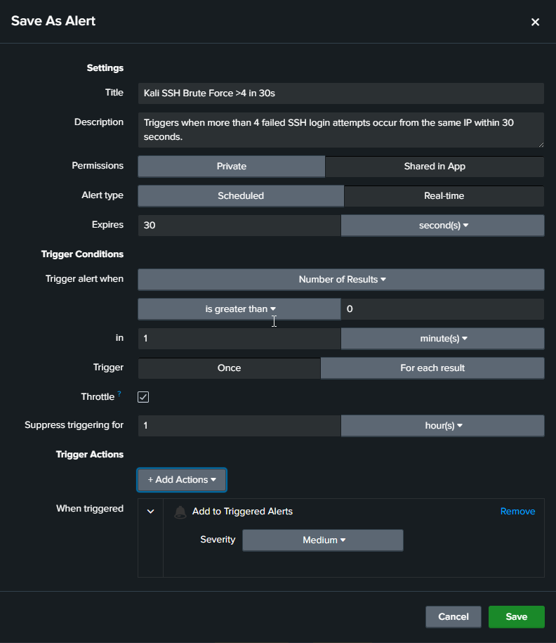
4.3.1

4.3.2
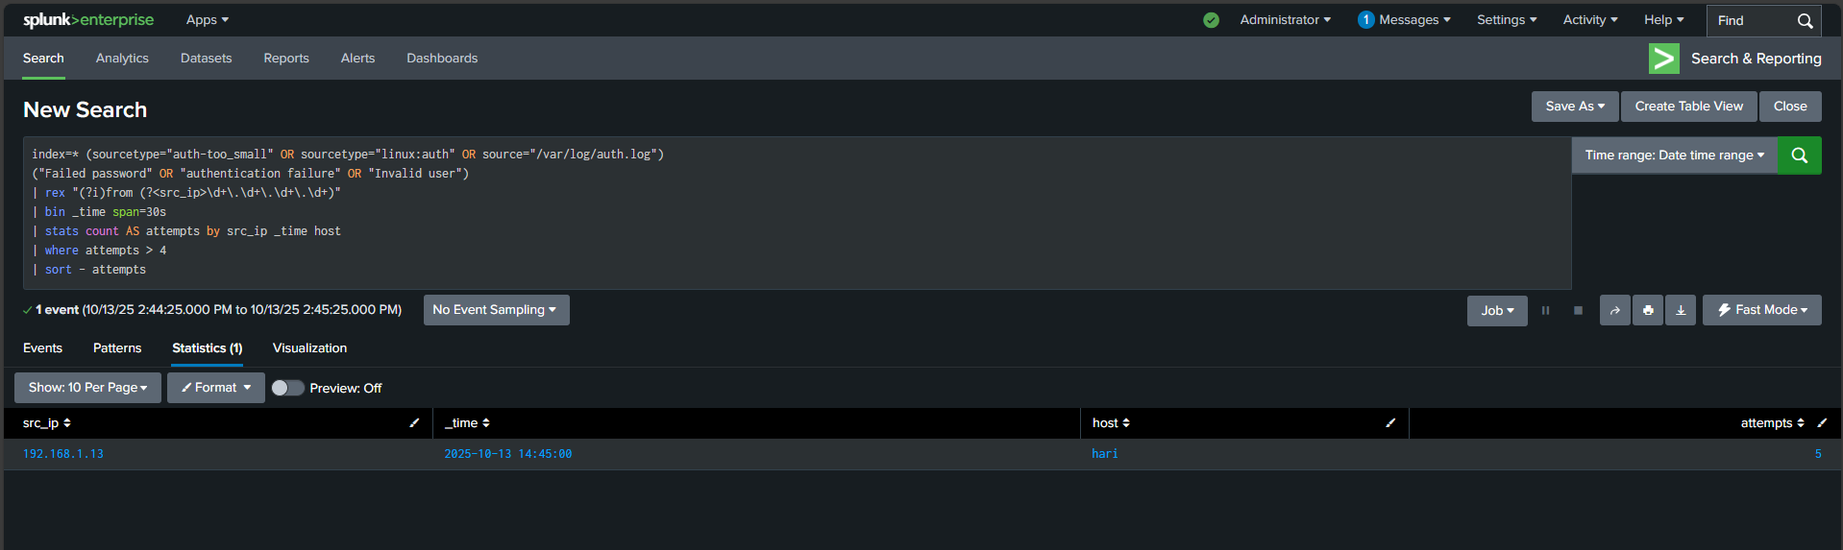
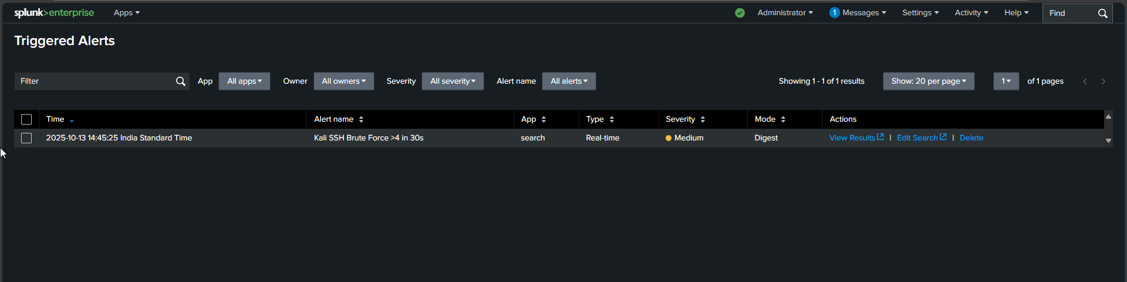
4.3.3

4.4 Summary
The proposed Splunk-based monitoring system will transform raw, unstructured log data into actionable intelligence. By automating data collection, analysis, and visualization, the system will significantly enhance IT operations, security monitoring, and overall infrastructure management. The expected outcomes align with the project’s objectives of achieving operational transparency, efficiency, and scalability in a cost-effective manner.

Diagram

5.1 UML Diagram

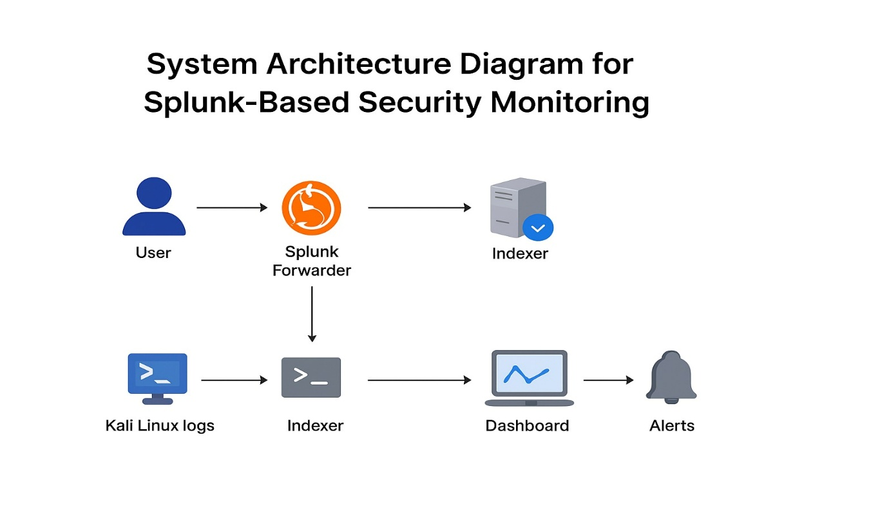

5.2 Process Diagram

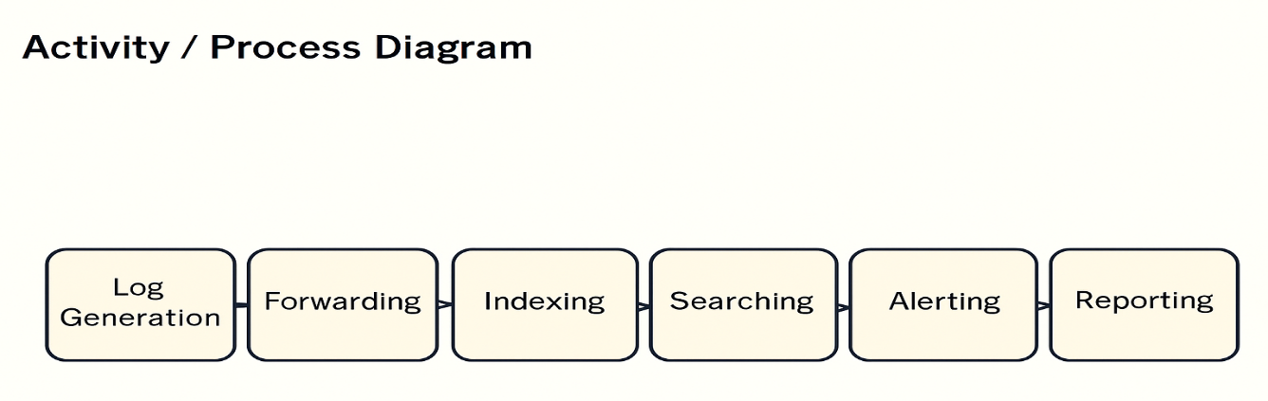

- Time line chart

6.1 Time line

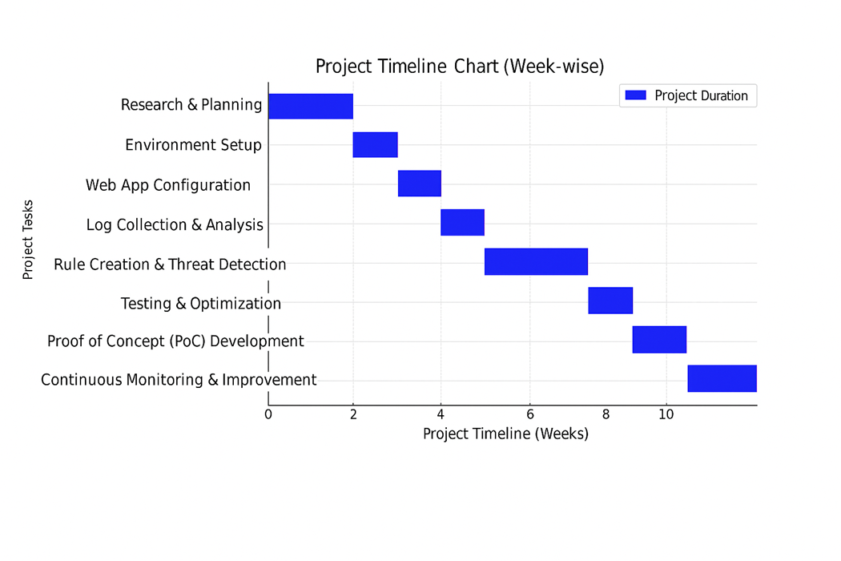

Future Work

While the implemented Splunk-based monitoring system successfully achieves real-time data collection, analysis, and visualization, there remain several opportunities for enhancement and expansion in future iterations of the project. The following points outline potential areas of future work:

- Integration with Automation and Orchestration Tools:
Future development can include integration with Splunk SOAR (Security Orchestration, Automation, and Response) or other automation platforms such as ServiceNow or Ansible. This would allow automated incident response actions, such as restarting services, isolating compromised systems, or notifying responsible teams without manual intervention.
- Implementation of Predictive Analytics and AI Models:
Advanced machine learning and artificial intelligence techniques can be applied to predict failures, detect anomalies, and identify potential security threats before they occur. By leveraging Splunk’s Machine Learning Toolkit (MLTK) and integrating custom Python models, the system can evolve from reactive monitoring to predictive intelligence.
- Enhanced Visualization and Business Intelligence (BI) Integration:
Future versions can incorporate more sophisticated visualization tools and integration with BI platforms such as Tableau or Power BI for deeper business-level insights and trend analysis. This would enable cross-functional teams to make strategic, data-driven decisions.
- Cloud and Multi-Cloud Monitoring Expansion:
With the increasing adoption of hybrid and multi-cloud environments, the system can be extended to monitor cloud-native services on AWS, Azure, and Google Cloud. Integration with Splunk Observability Cloud and Open Telemetry would provide full-stack visibility across infrastructure, applications, and microservices.

- Enhanced Security Analytics:
Incorporating Splunk Enterprise Security (ES) can elevate the system’s capability to detect and respond to complex security incidents. Future work may also focus on implementing threat intelligence feeds, user behaviour analytics (UBA), and compliance dashboards for better cybersecurity posture.
- Cost Optimization and Data Lifecycle Management:
Future efforts should explore data tiering strategies, such as moving older logs to archival or cold storage, to optimize licensing costs and storage utilization. Additionally, research can focus on automating data retention and compression without affecting query performance.
- User Experience and Customization Improvements:
Introducing more customizable dashboards and user-specific alerting preferences can improve usability. This can include role-based interfaces tailored to system administrators, developers, and management personnel.
- High Availability and Disaster Recovery:
Implementing full clustered architectures for the Search Head and Indexers, along with backup and disaster recovery mechanisms, will enhance system resilience and reliability in large-scale deployments.

Conclusion
- The Splunk-Based Monitoring System developed in this project demonstrates an effective approach to real-time monitoring, data analysis, and visualization for modern IT infrastructures. Through the integration of log data, performance metrics, and event information from multiple sources, the system provides a centralized and intelligent platform for maintaining operational visibility and reliability.
- The project successfully achieved its objectives by designing and implementing a scalable monitoring framework using Splunk’s core components — Forwarders, Indexers, and Search Heads — which collectively enable automated data collection, indexing, and analysis. The system’s dashboards and alerts offer real-time insights into infrastructure performance, application health, and potential security incidents, allowing organizations to take timely corrective actions and prevent service disruptions.
- Moreover, the solution highlights Splunk’s flexibility and extensibility, supporting diverse data sources and providing advanced analytics capabilities through the Search Processing Language (SPL) and Machine Learning Toolkit (MLTK). The resulting system not only enhances situational awareness but also enables data-driven decision-making and improved incident response efficiency.
- While the current implementation achieves robust monitoring and alerting functions, it also lays the foundation for future enhancements such as predictive analytics, automation, and integration with cloud-native observability tools. These advancements can transform the solution from a reactive monitoring system into a proactive, intelligent, and self-healing infrastructure management platform.
- In conclusion, the Splunk-based monitoring system contributes significantly to improving operational efficiency, reliability, and security in IT environments. It serves as a scalable and sustainable model for organizations aiming to achieve end-to-end observability, faster incident response, and continuous service optimization.

References

https://docs.splunk.com/Documentation/InfraApp/2.2.5/User/Alerts

https://help.splunk.com/en/splunk-cloud-platform/alert-and-respond/alerting-manual/9.3.2411/alerting-overview/getting-started-with-alerts

https://www.splunk.com/en_us/blog/learn/database-monitoring.html

https://www.splunk.com/en_us/blog/security/monitor-for-investigate-and-respond-to-phishing-payloads-with-splunk-enterprise-security-content-update.html

https://www.fortinet.com/resources/cyberglossary/what-is-splunk

https://www.splunk.com/en_us/products/infrastructure-monitoring-features.html

https://www.splunk.com/en_us/training/splunk-fundamentals.html

